Online Auction

Install Manual

**Slippery Rock University of Pennsylvania**

Contributions by:

**Spring 2024**

Tiffany Morrow – tbm1005@sru.edu

Wolfgang Zoppelt – wsz1001@sru.edu

Nicholas Vioral – ncv1005@sru.edu

Jacob Johnston – jrj1014@sru.edu

# Table of Contents

Table of Contents 2

[Step 1] Eclipse Installation 3

[Step 2] MySQL Installation 4

[Step 3] Eclipse Workspace Configuration 7

[Step 4] Run and Access Via Web Browser 9

# 

# [Step 1] Eclipse Installation

1. Download Eclipse Installer from [2023-09 R | Eclipse Packages](https://www.eclipse.org/downloads/packages/release/2023-09/r), ensuring to select the one for your operating system.  
     
   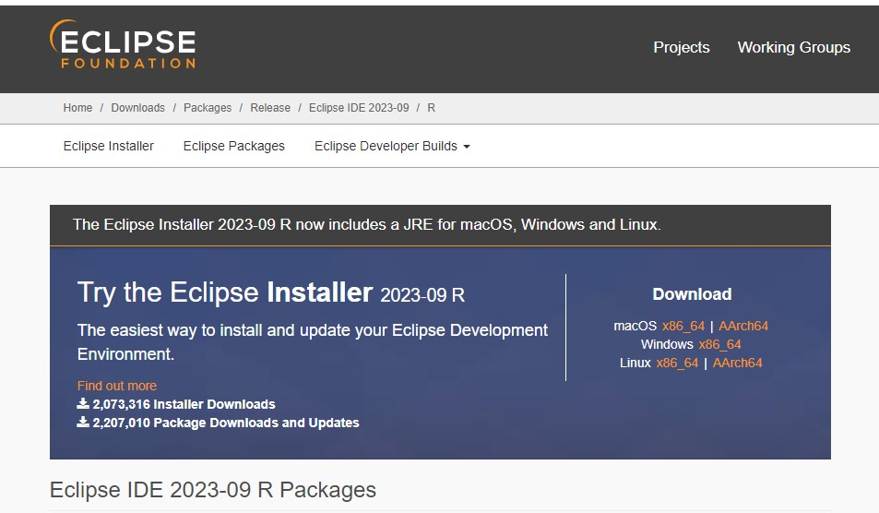
2. Run the Eclipse installer
3. Select JRE 17.0.10  
   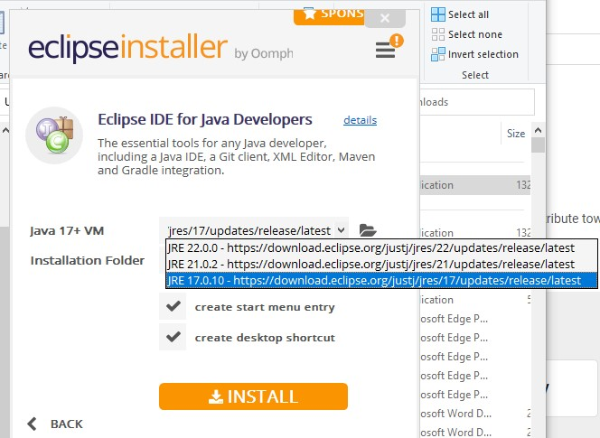
4. Click install to start the process.

# [Step 2] MySQL Installation

1. Download MySQL from <https://dev.mysql.com/downloads/installer/> , making sure you select the correct installer for your OS (Windows, linux, etc.)  
   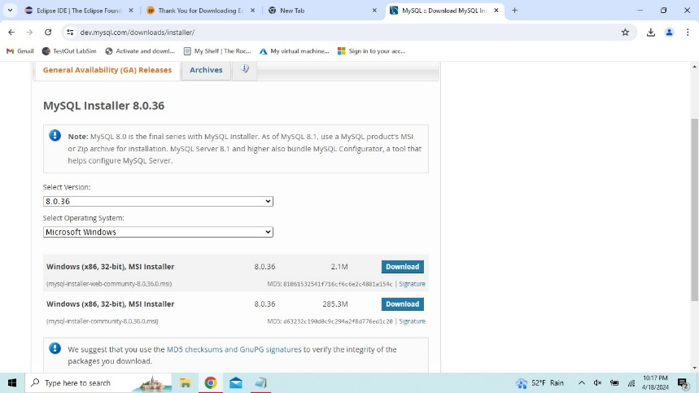
2. Once downloaded, run the MySQL installation wizard ensuring to choose custom install.  
   A screenshot of a computer

   Description automatically generated
3. Then Select the following components to be downloaded.  
   A screenshot of a software

   Description automatically generated
4. Click Next, and allow the components to be downloaded.
5. Follow these steps for Configuration.
   1. Keep the default setting and ensure that the Port is 3306.  
      A screenshot of a computer

      Description automatically generated
   2. Click Next until you come into the page to set your root password, You may set it to whatever you would like.  
      A screenshot of a computer

      Description automatically generated
   3. At this time for ease of running the project you can create another User for the project to use.
      1. Click Add User.
      2. Enter User Name: springuser
      3. Ensure the role is DB Admin
      4. Set Password to ThePassword
      5. Then hit OK button  
         A screenshot of a computer

         Description automatically generated
      6. This will ensure you will not have to update the application.properties before running the program.
   4. Continue clicking through the install wizard next, next, execute, finish.
   5. For the finished product configuration
      1. Click next and then finish
   6. This should complete the installation guide for MySQL, if you have the database schema titled ‘sellingwidgets’, ensure you right click and drop schema before running.

# [Step 3] Eclipse Workspace Configuration

1. Open Eclipse
2. Choose “Spring-2024-Online-Auctioning-“ as the workspace
3. Wait for eclipse to build
4. In the toolbar, select Help then Install New Software
   1. In the “Work with:” copy and paste this URL:  
      <https://projectlombok.org/p2>  
      A screenshot of a computer

      Description automatically generated
   2. Select Lombok, then click Next
   3. Click Next
   4. Accept the terms and agreements and install
   5. Eclipse will prompt to restart, accept and allow eclipse to load again
5. In the toolbar, select help then open Eclipse Marketplace
   1. There are a couple plugins that need installed
      1. Spring Tools 4
      2. Thymeleaf plugin
      3. Eclipse Tomcat Plugin
      4. PlantUML (optional)
   2. Search for the Titles in the search bar  
      A screenshot of a computer

      Description automatically generated
   3. After they appear click the install button
   4. Accept the terms of the license agreement
   5. Then click Finish
6. In the toolbar, Select File then Import
   1. Under Maven, Select Existing Maven Project
   2. Select Browse
   3. Select the workspace folder: “Spring-2024-Online-Auctioning-“
   4. Select the pom.xml file and then click Finish

# [Step 4] Run and Access Via Web Browser

1. Run SellingWidgets.java in Eclipse
   1. To do this right click SellingWidgets.java
   2. Mouse over Run As:
   3. Click Spring Boot App
2. Please wait for SQL import to complete.
3. In a web browser, enter the following URL: <https://localhost:8443>
4. To use the site for testing, without creation of a new account, use the following credentials:
   1. Basic User Account
      1. Username: userName
      2. Password: testPass
   2. Admin Account
      1. Username: newadminwidget
      2. Password: thisismypass